**NAME**: VINEETH REDDY ANUGU

**STUDENT ID**: 2836349

**LOGIN** **ID**: vianugu@grail.eecs.csuohio.edu

**Course Project(Apriori)**

**Aim :** Implement apriori algorithm based on the given pseudo code and running it on a website.

**Tools:** Python, Flask, Heroku, Google cloud platform, gunicorn, Pycharm

**Steps:**

* Initially to implement apriori, I used pycharm IDE to write code.
* The given pseudo code was

­

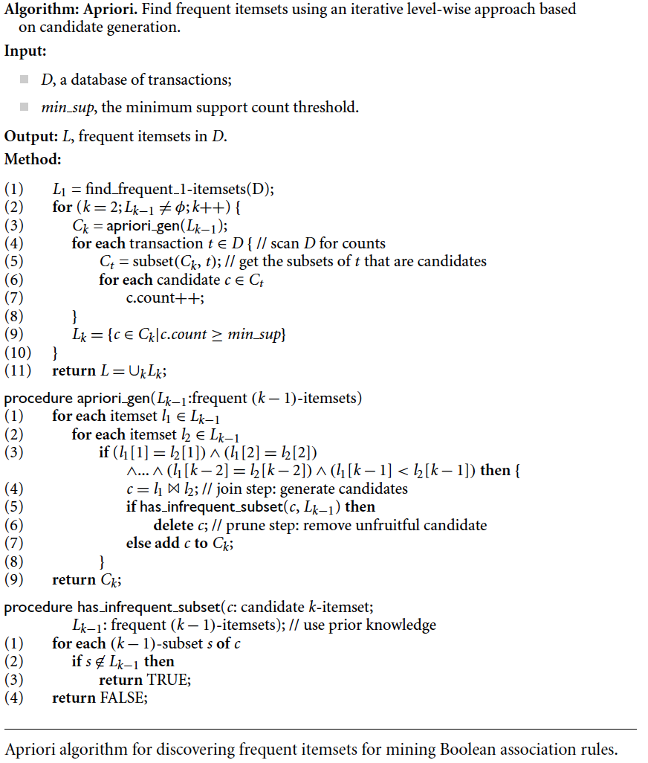

* Initially I created an python file called apriori.py which would implement the above algorithm
* We had 2 main procedures
  + Apriori_gen()
  + Has_infrequent_subset()
* The flow of code would be as follows:
* First, we take an input file from the user to run our algorithm, this file is a CSV files and is uploaded via the website.
* This file will be stored in a temporaryfile folder within the webapp, which is later loaded again to clean the data.
* Also, min_sup (minimum support) value is taken from user input.
* Then dataset is taken and cleaned to use in further steps.

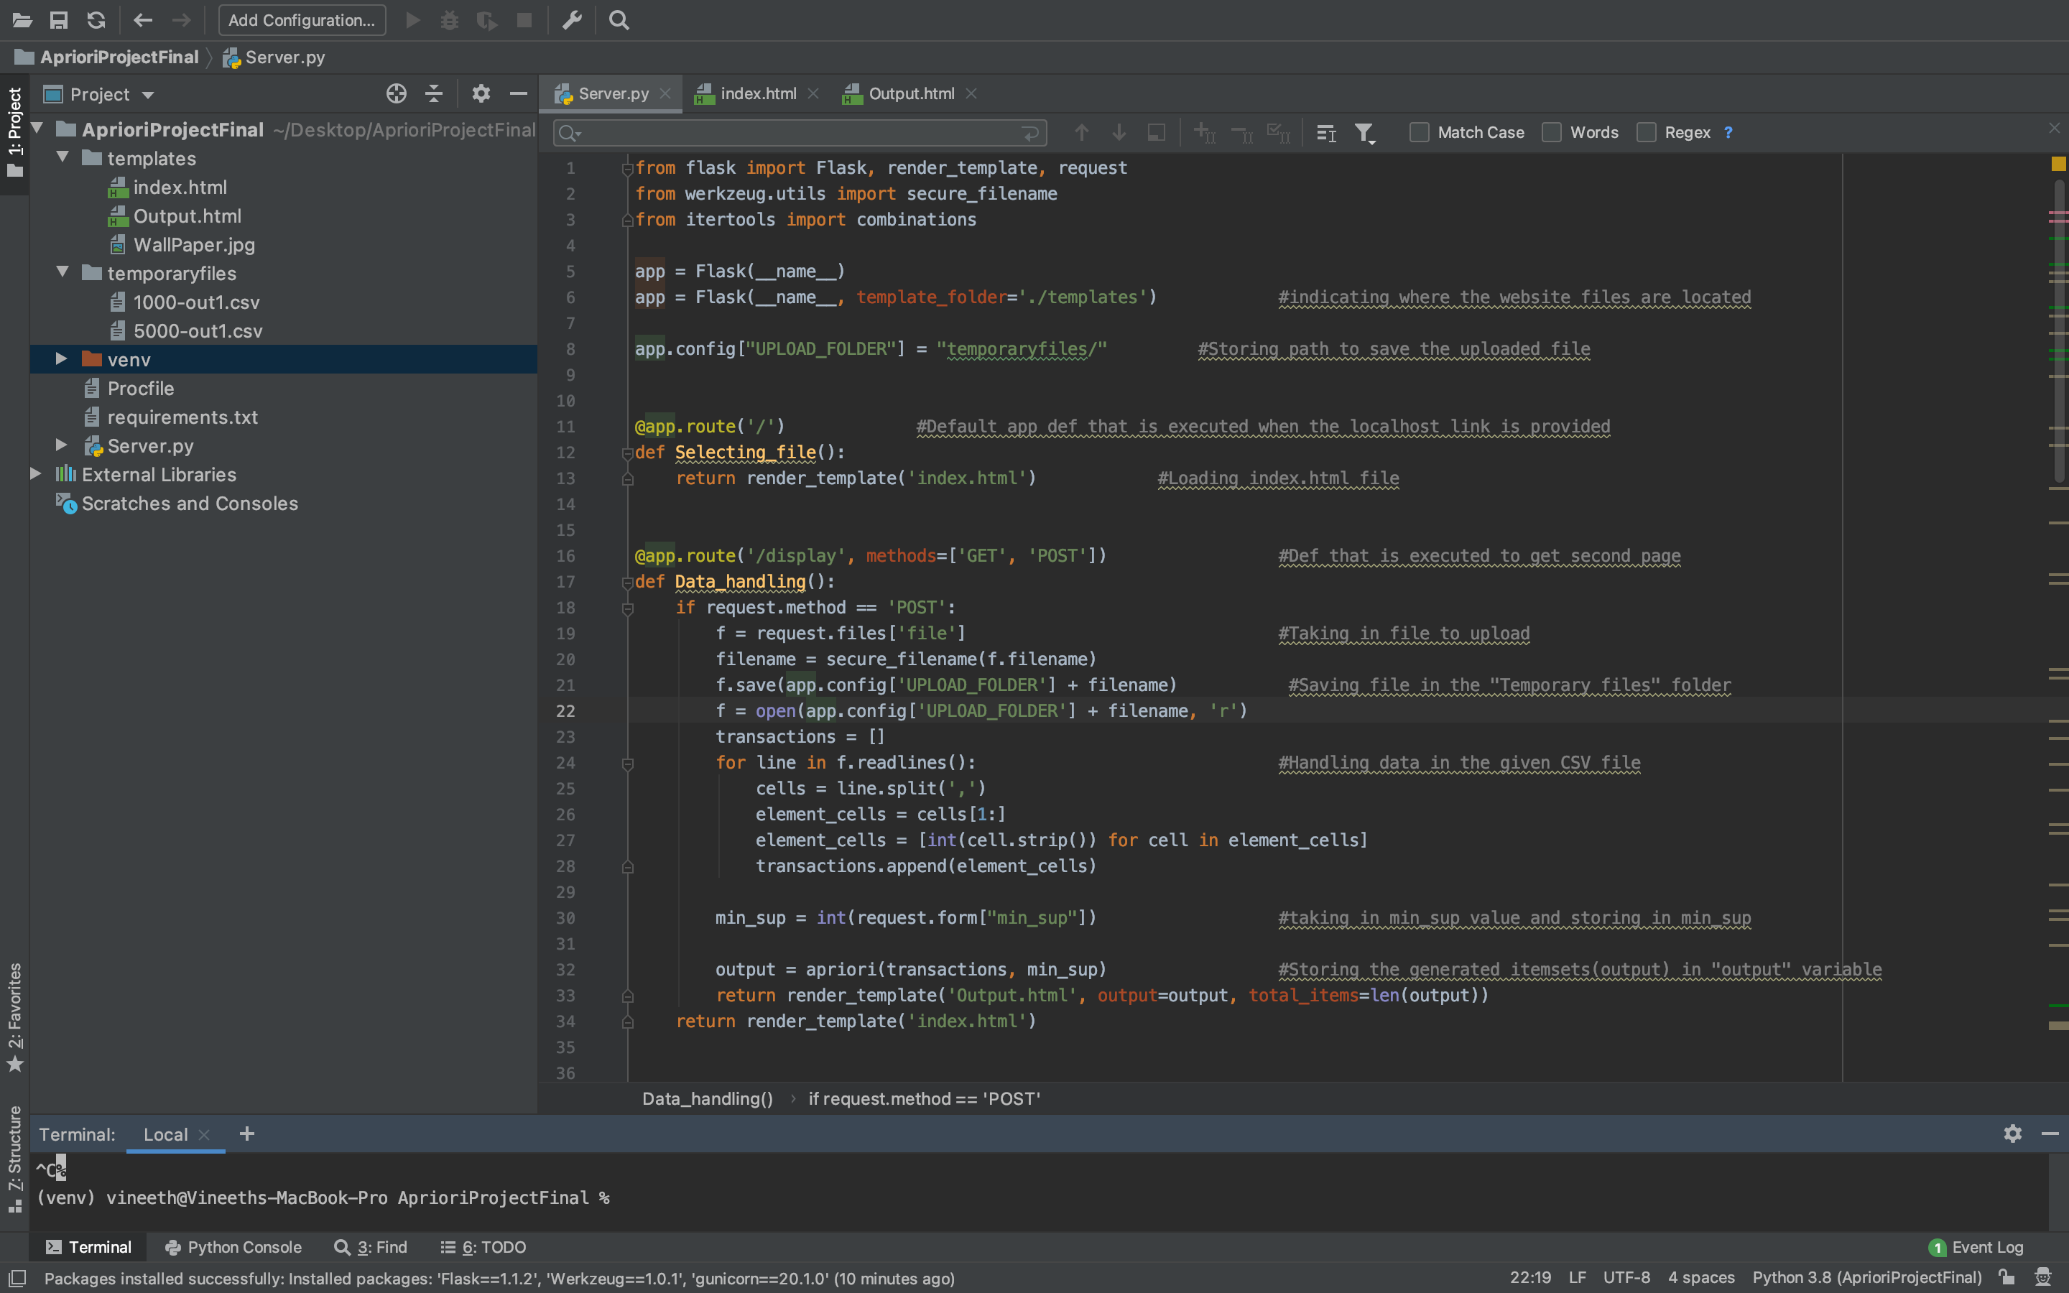



* Now, the first function to be called is apriori():, where we call functions to generate various levels of frequency item sets
* Next, find_frequent_itemset(): is called to find level 1 frequency item sets.

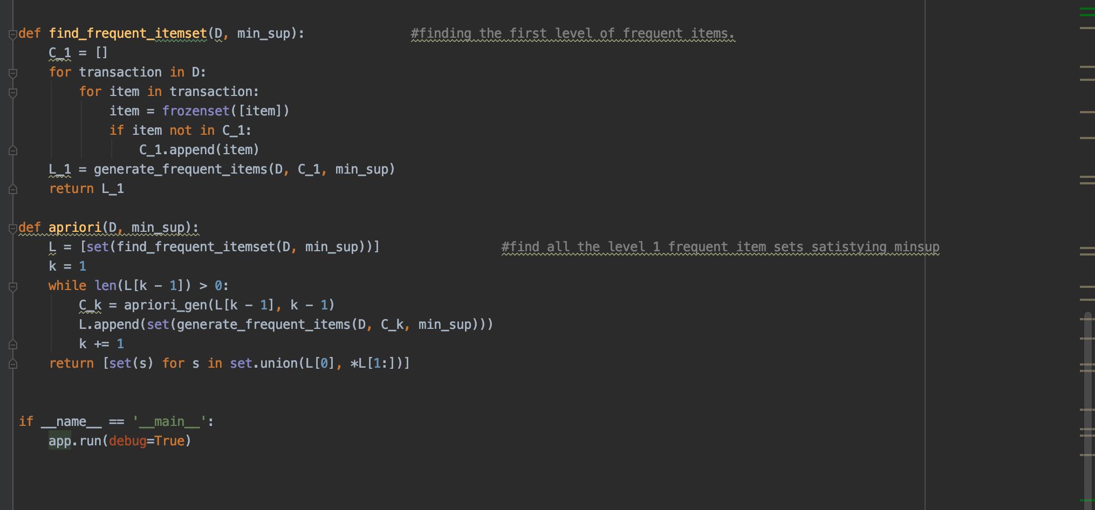

* Next apriori_gen() function is called to call the joining and pruning steps depending on the condition

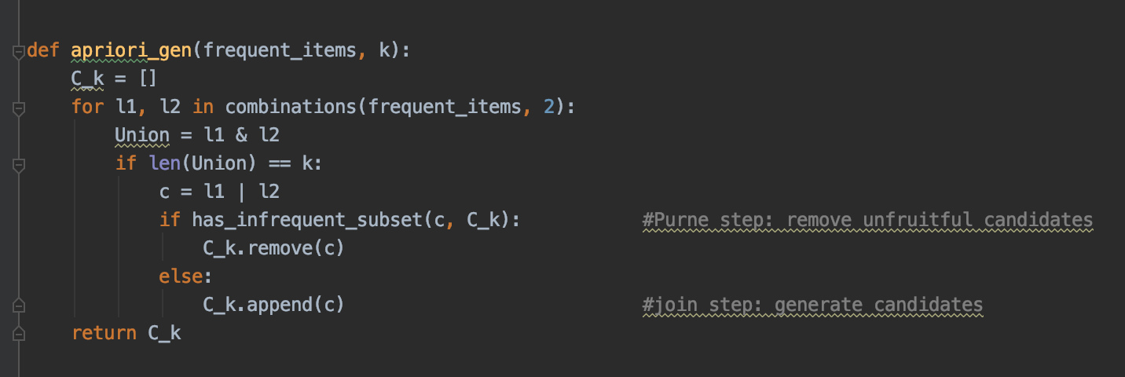

* Now, generate_frequent_itemset() function will generate frequency itemsets depending on our requirements.

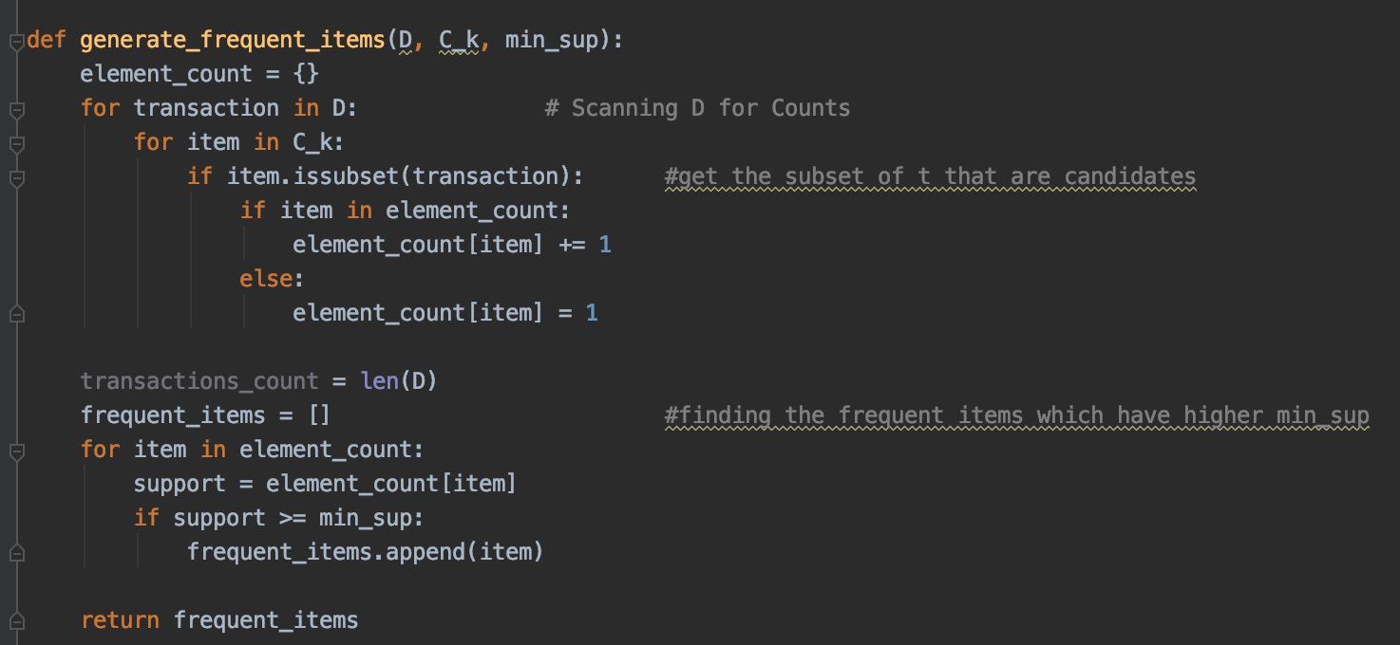



**OUTPUT:**

The output of the above code will be as follows

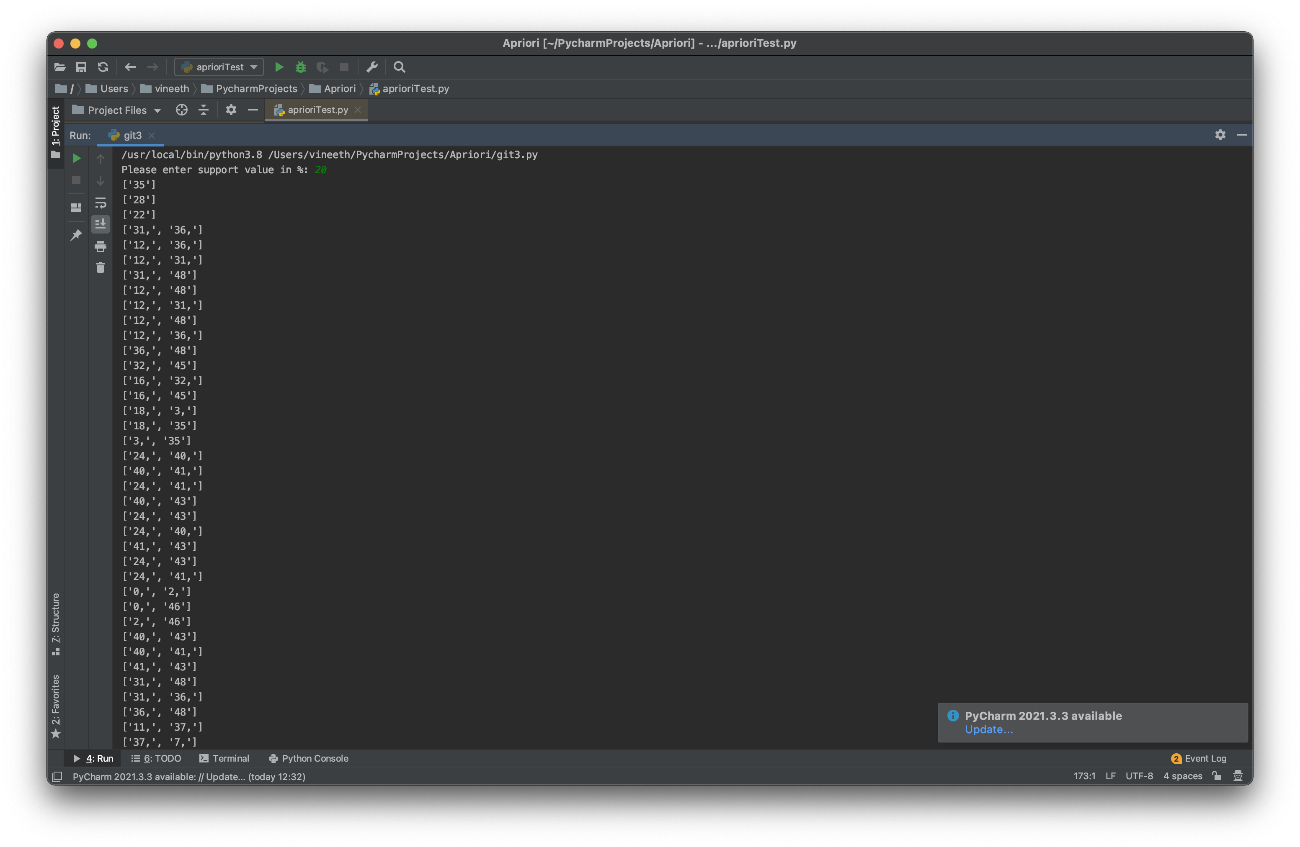

**Now to run on a webpage.**

* To run the application on a webpage we use Flask framework.
* This framework allows us to gave various API calls using “@app.route”.
* Hence, we import flask package to our application
* All the HTML and CSS files are put inside “TEMPLATE” folder of our app
* Then we create an initial API (“/”) call for our first page of the application.
* Our first page of project will be the page where we take the value of minimum support.

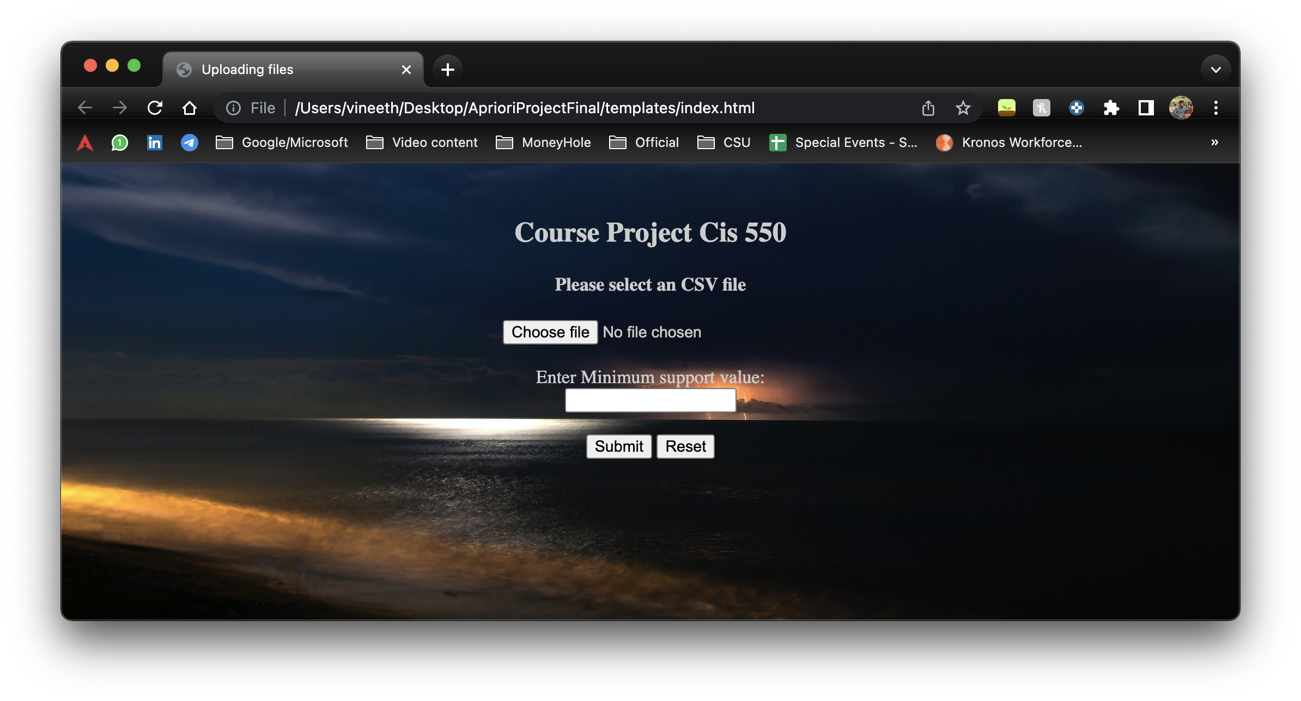

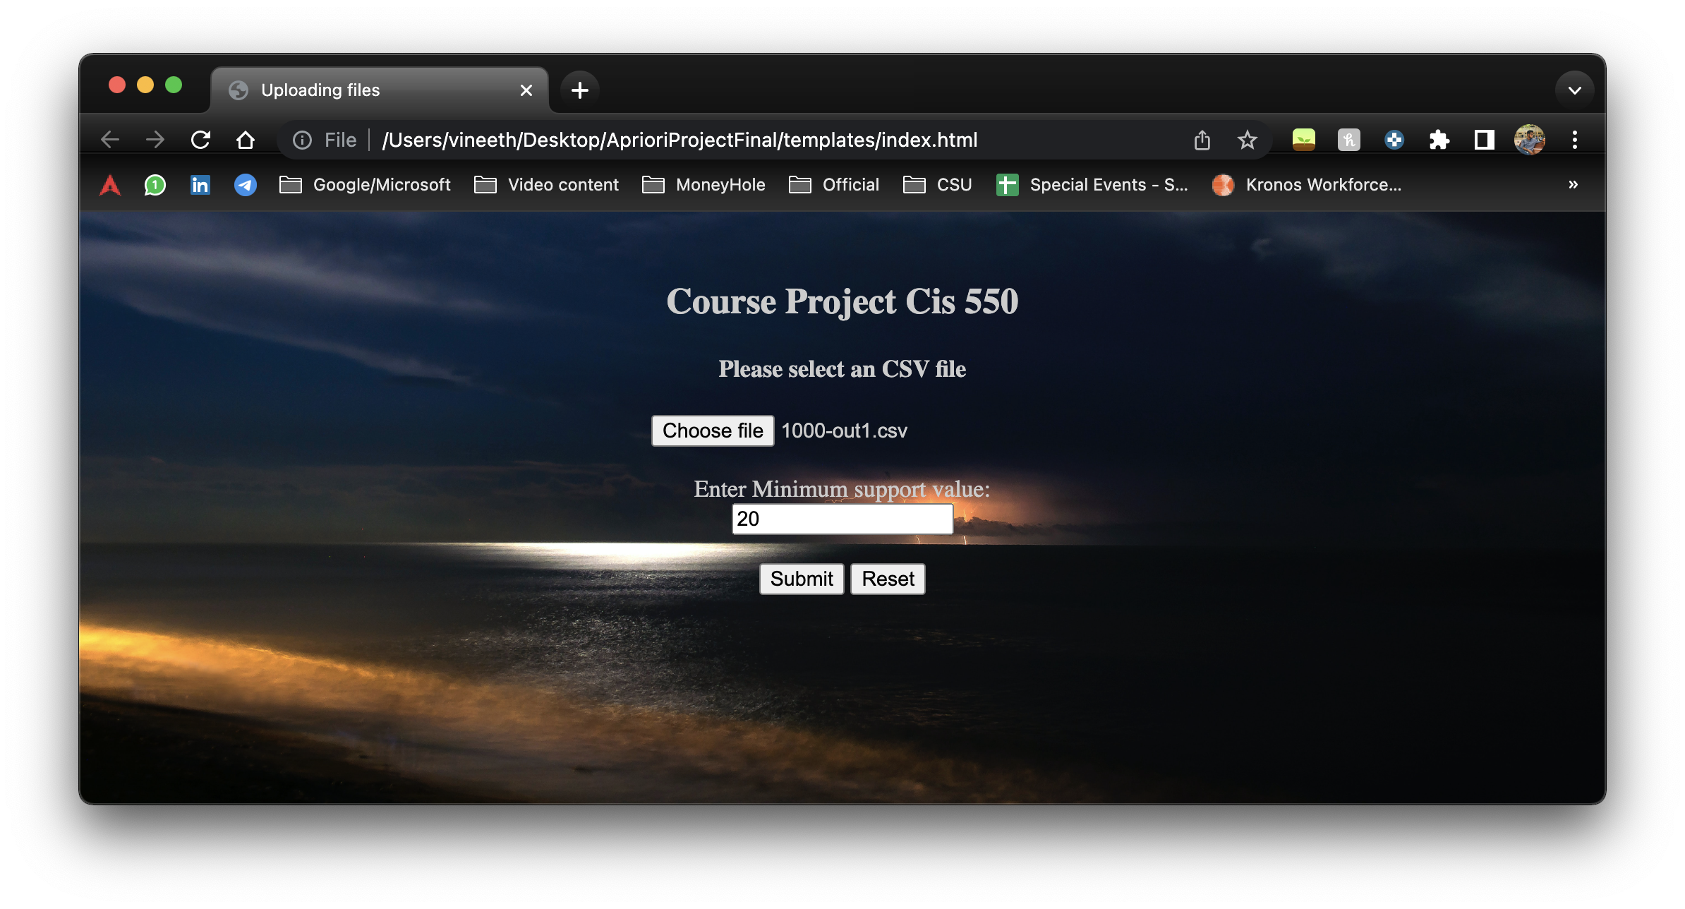

* Once we give value of minimum support, the submit button will call “/Output” API, where the value of minimum support is sent to our apriori code as min_sup.
* Once the value is processed, the apriori code runs and it is printed to the html page “Output.html”

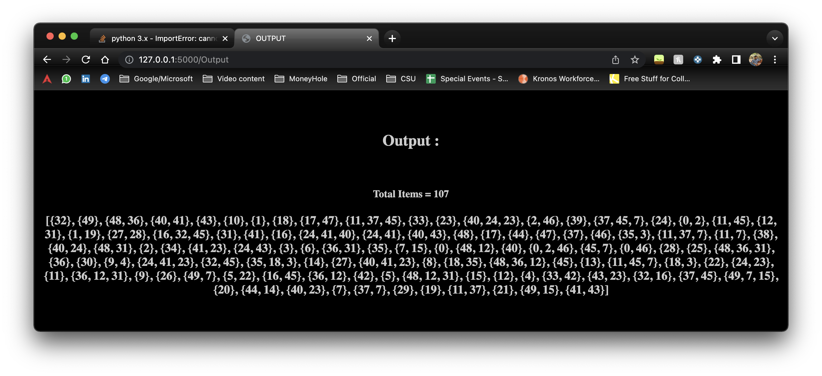

* For the project to run on local server, we have to run the following code in terminal “python3 Server.py”
* This will initiate the local host server and run “/” API

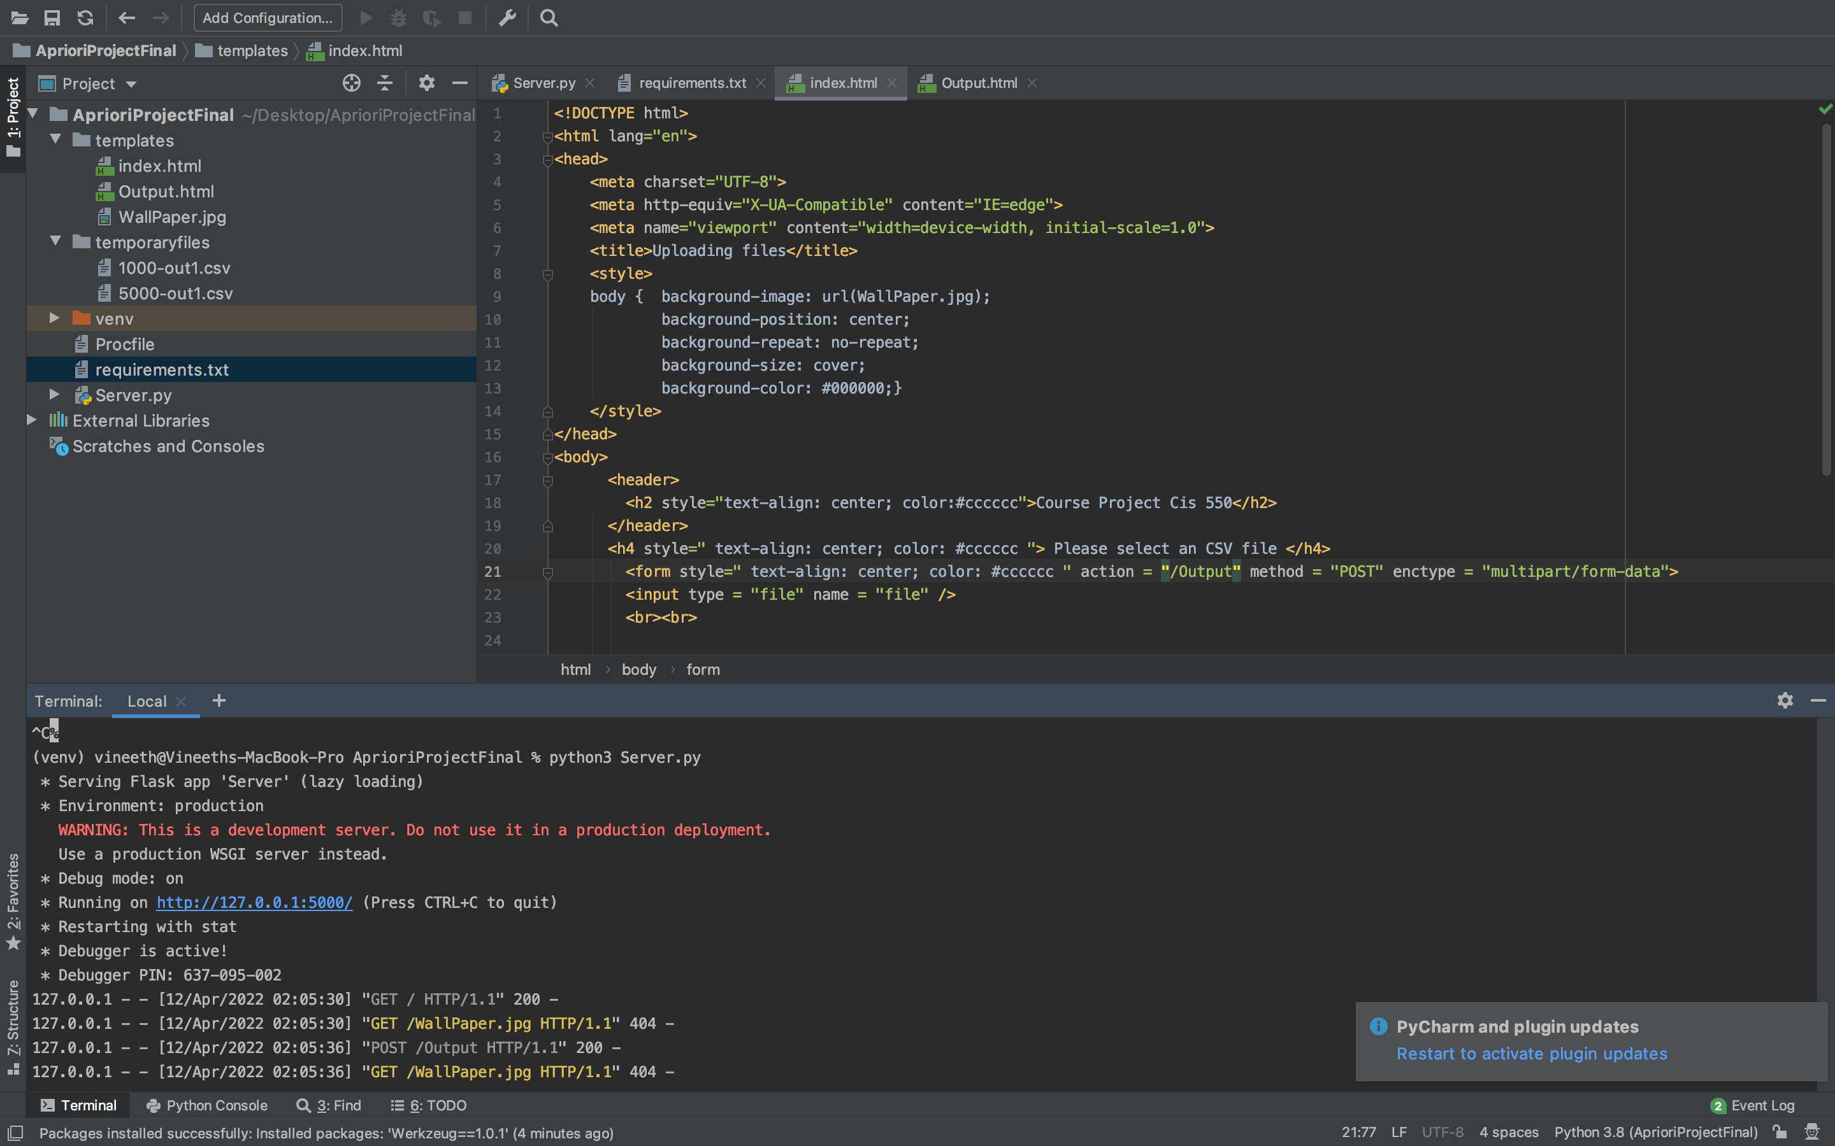

**Now to host the app on cloud platform:**

* I have selected Heroku website to deploy my app onto cloud.
* To deploy my app I had to create a reqirement.txt file which contains all the requirements to run the app
* This was done using “pipreqs” in terminal.

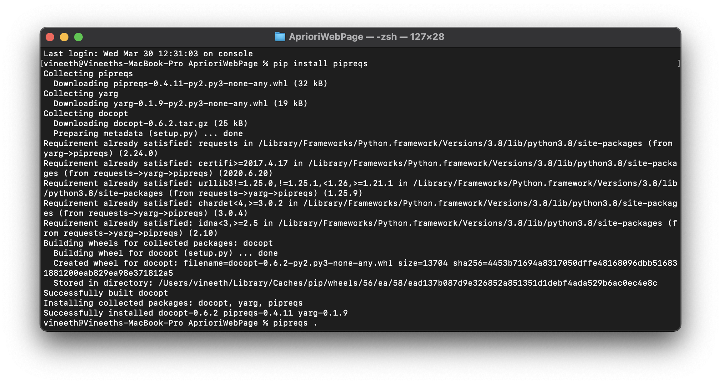

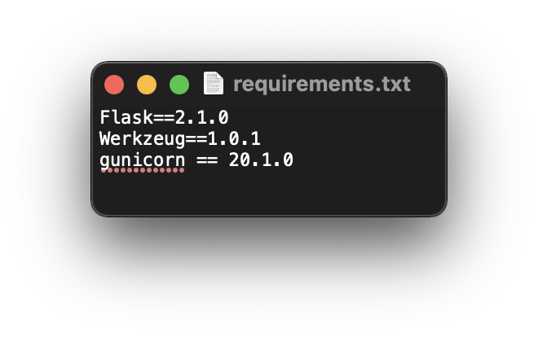

* We also install gunicorn which is a Python server interface.
* Now we create a Procfile without any extention which is a mandatory file to run app on Heroku cloud.

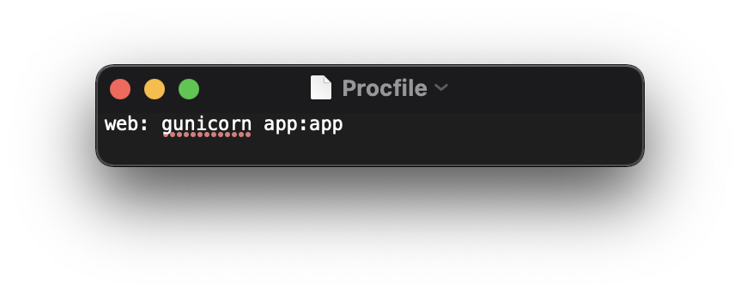

* We use this procfile to tell the server where to run the initial steps of the app.

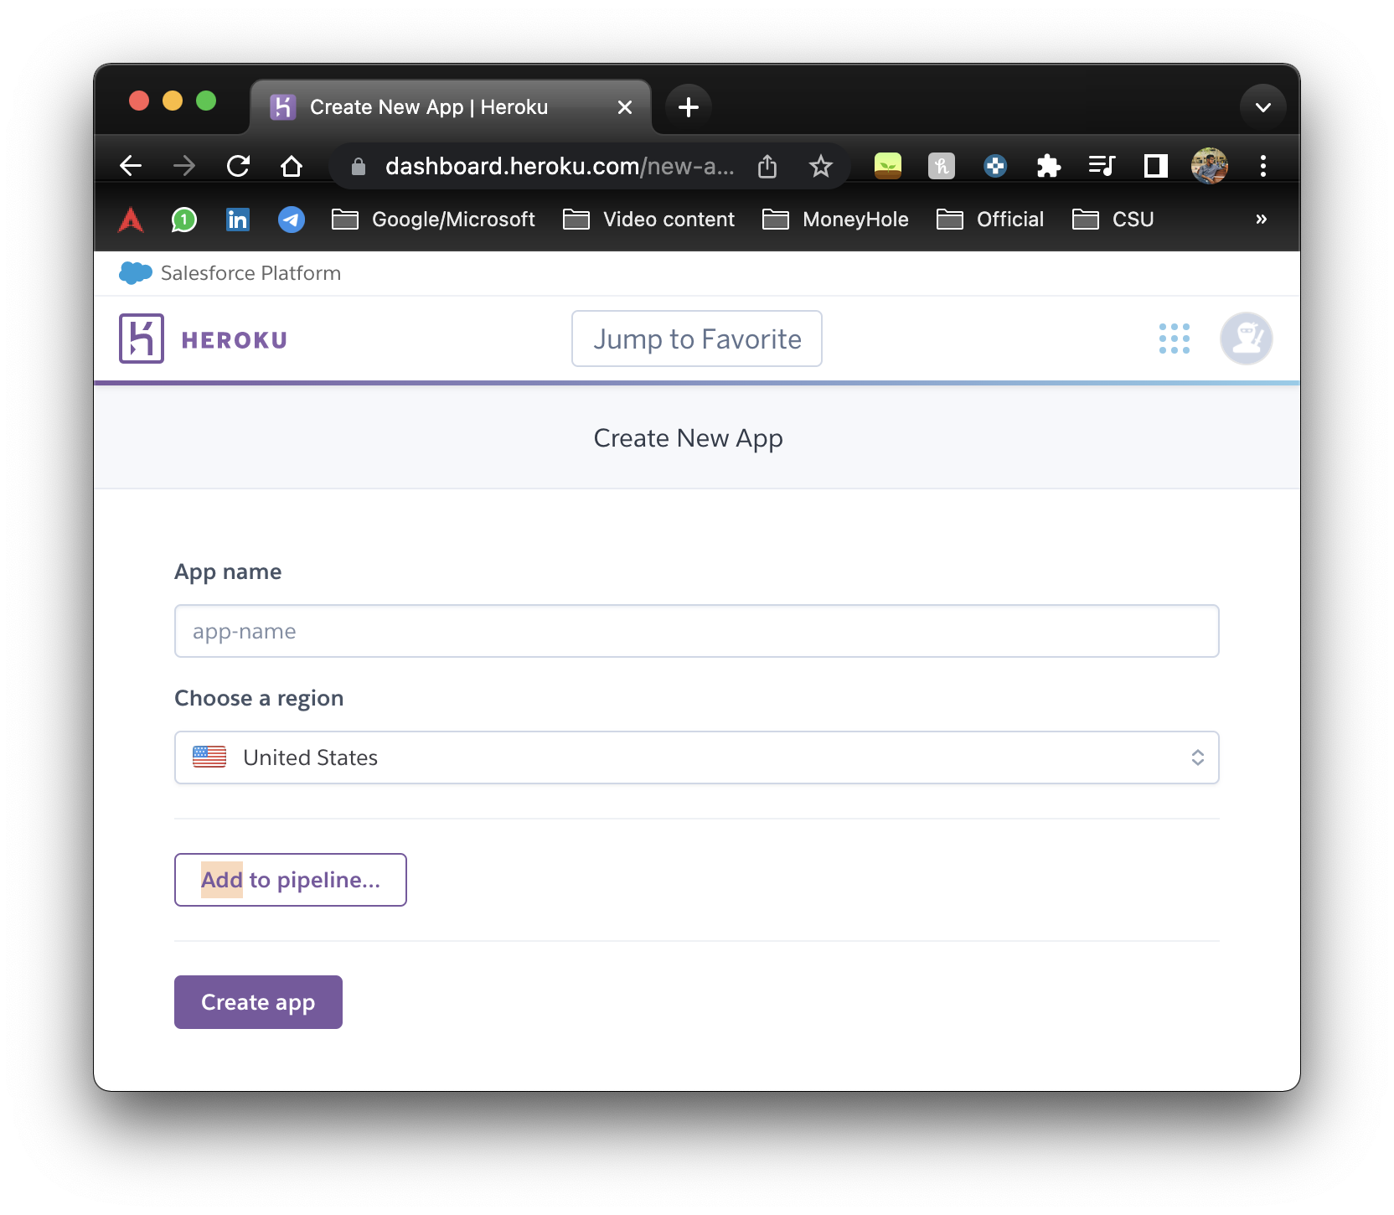

* Once, out app is created we line our Heroku with our git repo

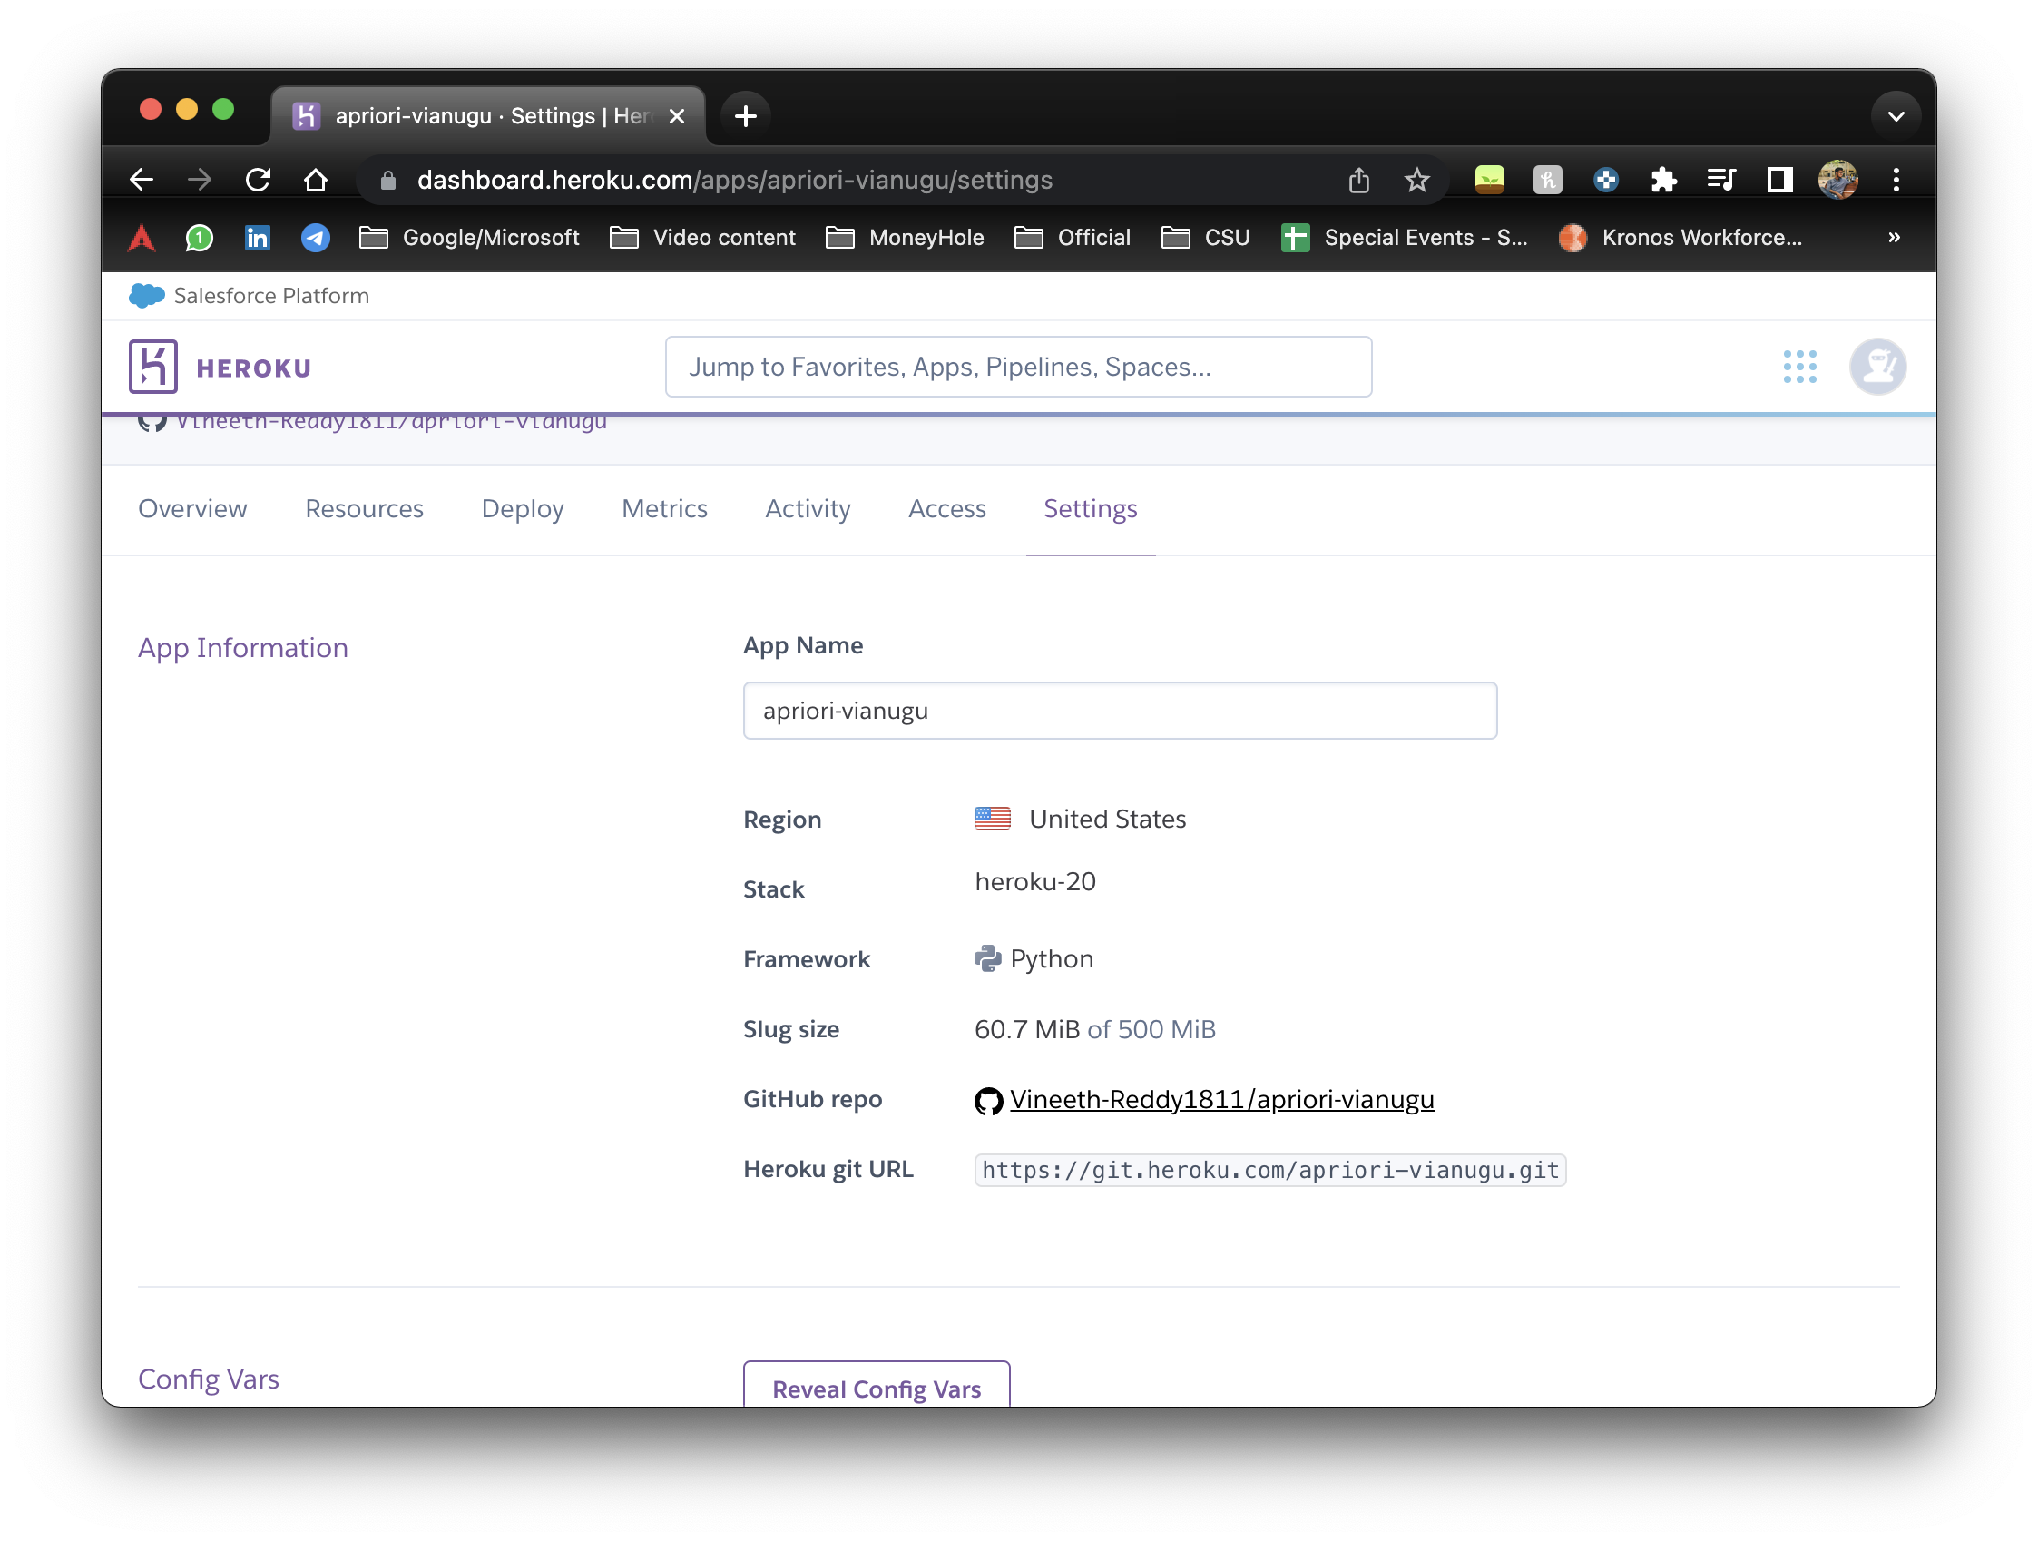

* Once our git is connected we build our app so that all the requirements in “requirement.txt” will be downloaded

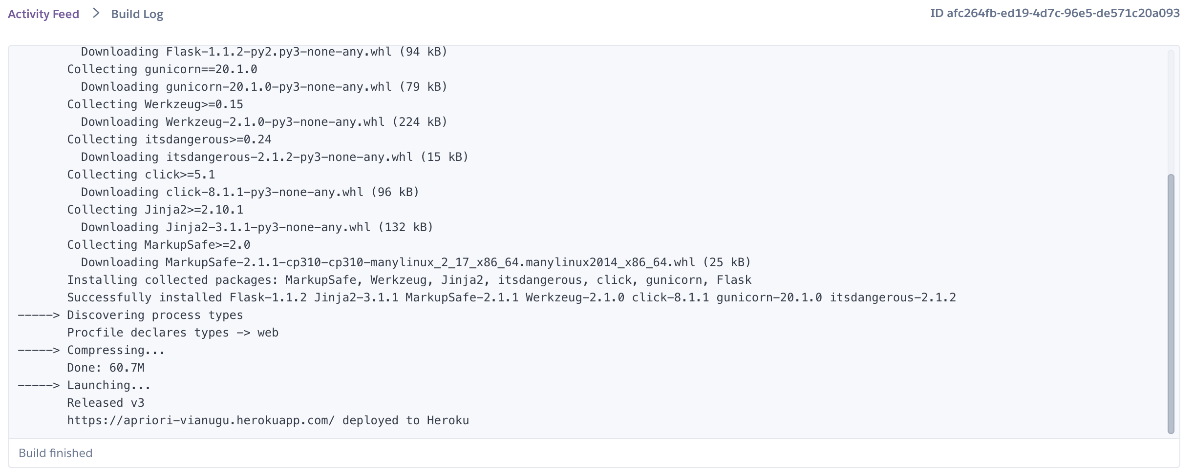

* The project is now deployed on link “https://apriori-vianugu.herokuapp.com/”

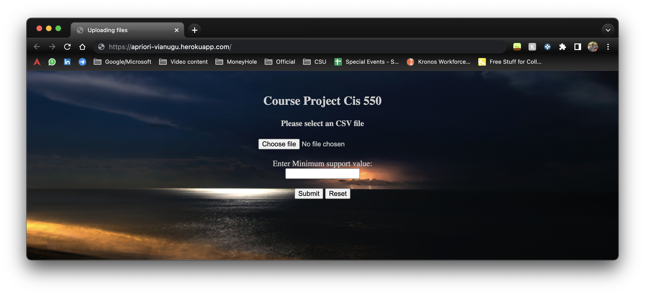

* But due to some bugs in my code I am getting error code: H10 error in heruko.

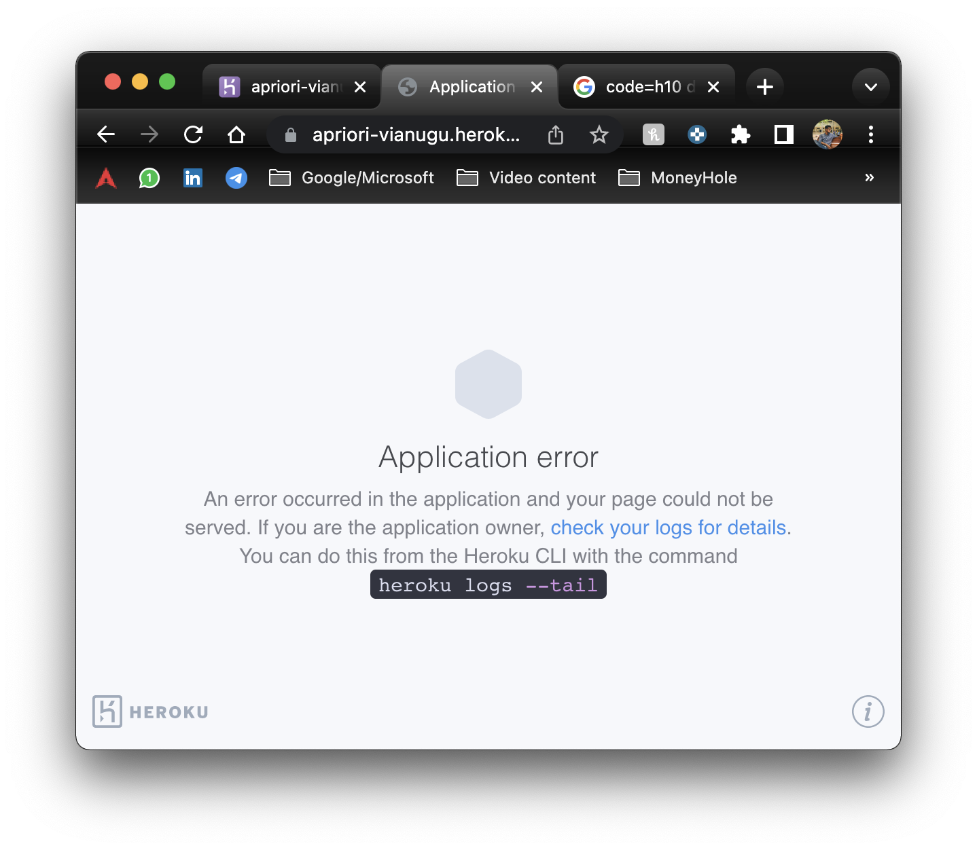

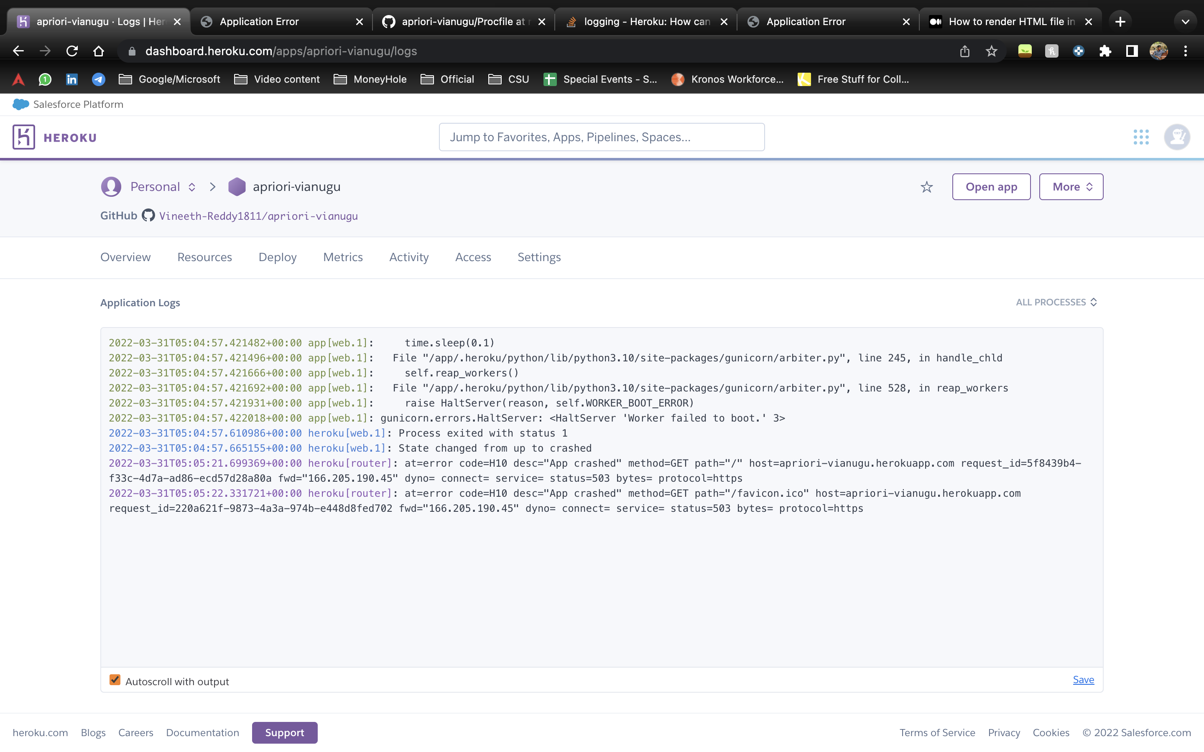

* Also, as my apriori code doesn’t take handle dataset inside a function. I was not able to select and send data as input. And when. I tried to put it in a function, the other variable would become local variable making it further complicated

**OUTPUTS OF VARIOUS DATASETS (with min_sup = 20) :**



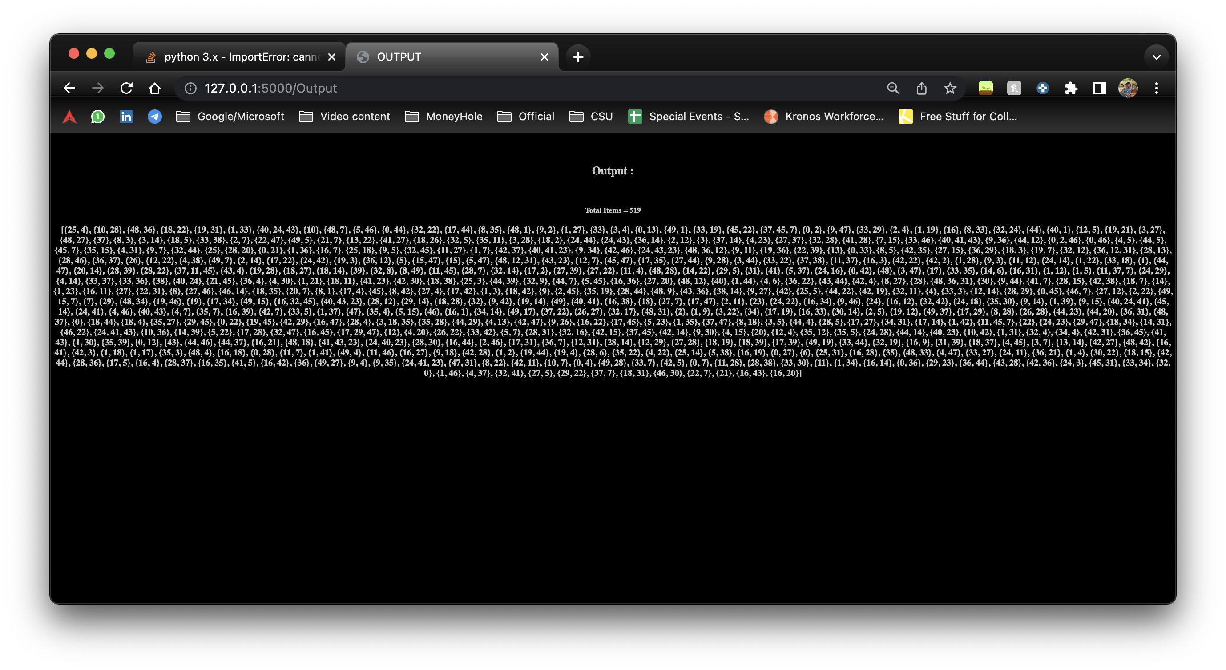

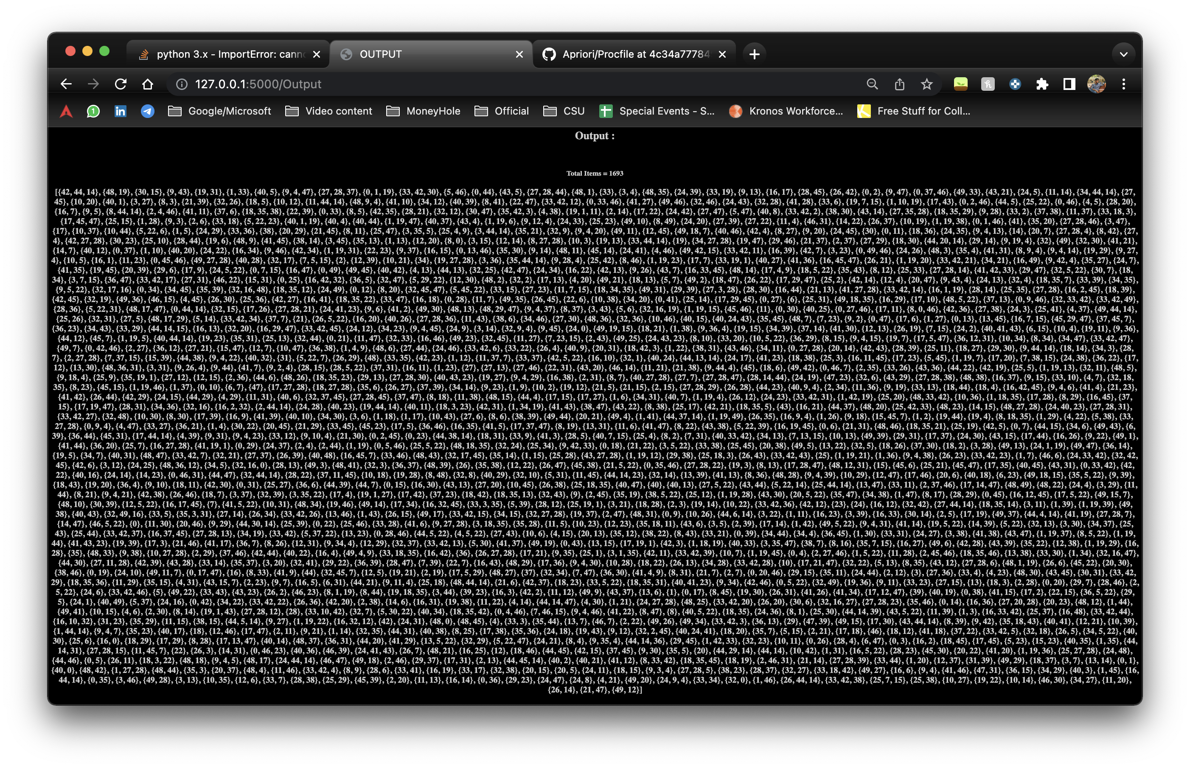

**REFERENCES**

* HerokuDocumentation: <https://devcenter.heroku.com/categories/python-support>
* W3Schools: <https://www.w3schools.com/html/default.asp>
* Geeksforgeeks: <https://www.geeksforgeeks.org/deploy-python-flask-app-on-heroku/>
* VideoReferences: <https://www.youtube.com/watch?v=s6Xi7x4G7yg>